Course Hierarchy
The diagram below shows the development and organization hierarchy for Epi-Workbench (EWB) courses. Each element of the hierarchy is discussed below the diagram.
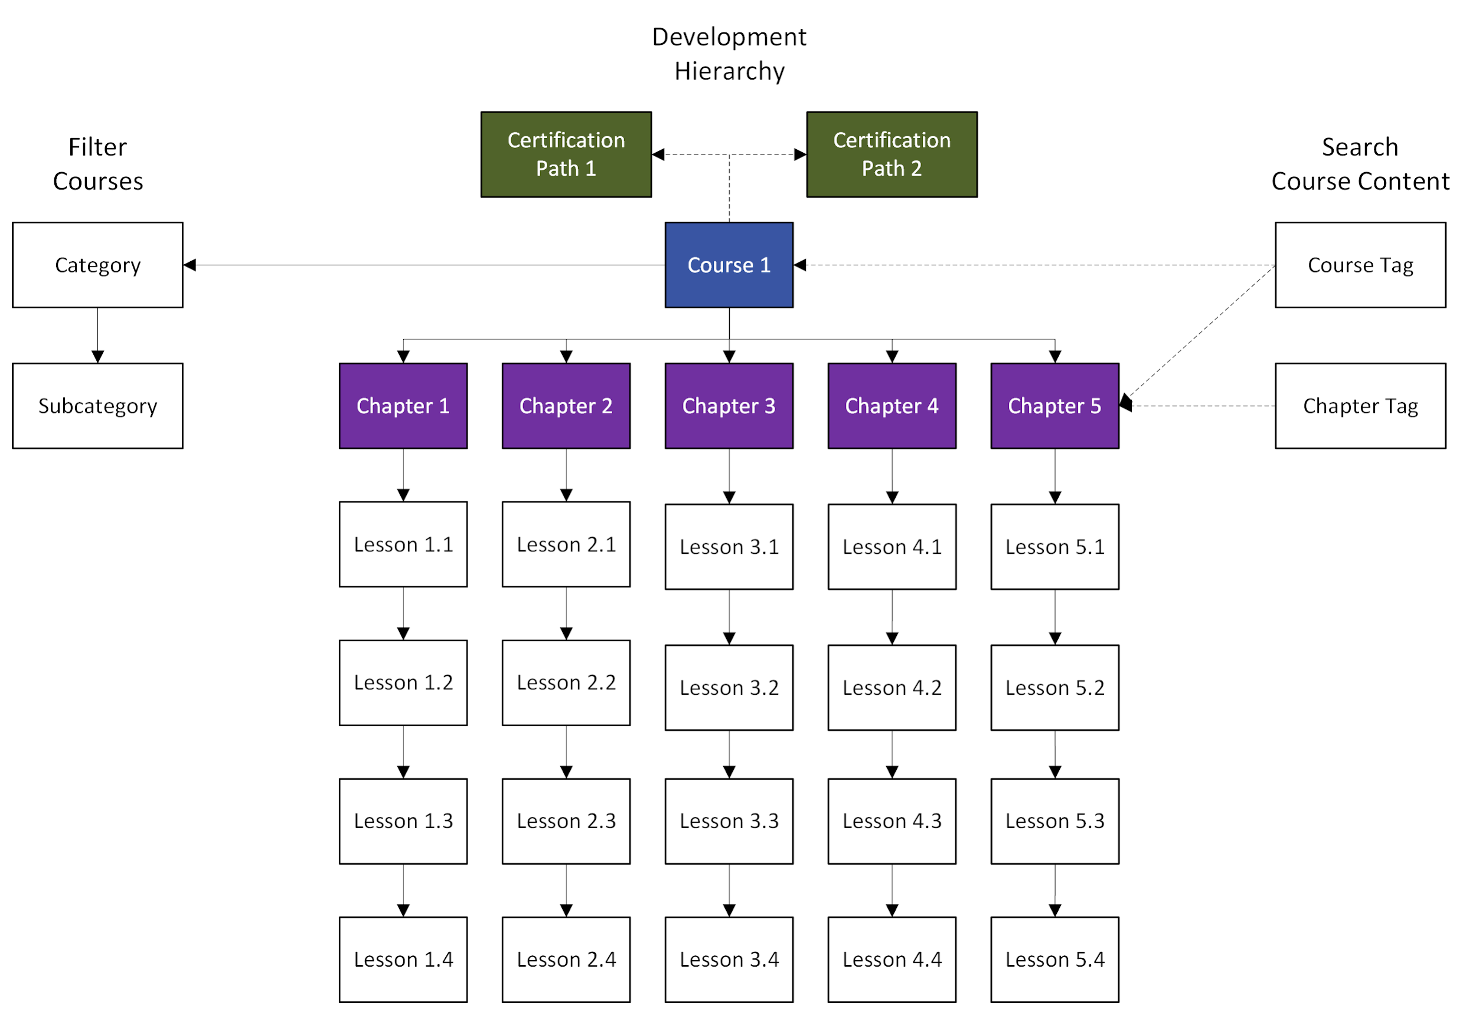
Figure 1. Course Development and Organization Hierarchy.

Skill path
Skill paths are structured collections of courses designed to help learners develop a distinct skillset or demonstrate competencies required for a particular career or position. While optional, these paths provide a guided curriculum for learners seeking structured skill development. Upon completion, learners receive a digital certification that can be shared with others, including prospective employers.

In Figure 1, skill paths are linked to courses using dashed lines, signifying their optional nature. Learners are not required to follow a skill path, and individual courses may or may not be part of one. However, a single course can be included in multiple skill paths, allowing flexibility in how learners build their expertise.

Examples of skill paths include:
- Fundamentals of R Programing
- Fundamentals of Epidemiology

See Appendix A for more examples of skill paths.

Courses

Courses are the fundamental unit of EWB content development and represent the highest-level required element in the course development hierarchy. In the initial phase of development, an EWB course will typically correspond to a chapter in the R for Epidemiology (R4Epi) textbook.

See Appendix B for examples of chapters.

Chapters
Courses consist of chapters, which represent the next level in the course development hierarchy. During the initial phase of development, an EWB chapter will typically correspond to a chapter section in the R for Epidemiology (R4Epi) textbook.

Lessons
Chapters consist of lessons, which represent the lowest level in the course development hierarchy. Each lesson is a single page of content on the EWB platform and falls into one of four types: written lessons, video lessons, coding exercises, and quizzes.

Categories
Categories and subcategories are used on the courses page to help learners filter and discover courses based on their interests. For example, a category might be Data Analysis, while a related subcategory could be Linear Regression.

In the initial phase of development, a category will typically correspond to a book part in the R for Epidemiology (R4Epi) textbook, ensuring alignment between course organization and the textbook’s structure.

See appendix C for more examples.

Tags
Tags are used to facilitate search and discovery of course content on the EWB platform. While subcategories help organize courses (e.g., Linear Regression), tags provide more granular detail, such as specific functions (lm or glm). The primary purpose of tags is to help learners search for the content.

Tags can be assigned to both courses and lessons. Additionally, lessons automatically inherit the tags assigned to their parent course, ensuring consistency in searchability and organization.

In Figure 1, tags are linked to courses and chapters using dashed lines, signifying their optional nature. Authors are not required to add tags to courses or chapters.

Appendices

Appendix A: Example Skill Paths
This appendix provides examples of potential skill paths. These examples illustrate how courses can be grouped to develop specific skill sets or competencies. However, this list is not exhaustive, and we may not implement all of the skill paths listed here. Additional skill paths may be developed as EWB evolves.
- Fundamentals of R Programing
- R Package Development
- Fundamentals of Epidemiology
- Intermediate Epidemiology
- Advanced Epidemiology
- Fundamentals of Causal Inference
- Intermediate Causal Inference Estimation
- Advanced Causal Inference Estimation
- Infectious Disease Epidemiology
- Chronic Disease Epidemiology
- Clinical Epidemiology
- Pharmacoepidemiology
- Epidemiology of Aging
- Certified in Public Health Exam Preparation

Appendix B: Example Courses
This appendix provides examples of potential courses that may be developed on the EWB platform. However, this list is not exhaustive, and we may not create all of the courses listed here. As EWB evolves, new courses and skill paths may be introduced to better align with learner needs. Additionally, you may view the course roadmap on GitHub at https://github.com/orgs/epi-workbench/projects/5. It provides up-to-date information on planned and in-progress courses.
- Introduction to the R programming language
- Introduction to coding tools and best practices
- Introduction to data transfer
- Introduction to descriptive analysis
- Describing the relationship between a continuous outcome and a continuous predictor
- Describing the relationship between a continuous outcome and a categorical predictor
- Describing the relationship between a categorical outcome and a categorical predictor
- Introduction to data management
- Creating and modifying data frame columns
- Filtering data frame rows
- Working with dates
- Working with character strings
- Conditional operations
- Working with multiple data frames
- Restructuring data frames
- Introduction to repeated operations
- Introduction to Git and GitHub
- Creating tables
- Creating visualizations
- Introduction to Epidemiology
- Introduction to regression analysis
- Introduction to predictive analysis
- Introduction to causal inference
- Introduction to study design

Appendix C: Example Categories
This appendix provides examples of potential categories and subcategories that may be developed on the EWB platform to help learners filter and discover courses based on their interests. However, this list is not exhaustive, and we may not create all of the categories listed here. As EWB evolves, new categories and subcategories may be introduced to better align with learner needs.
- Programming concepts
  - Tools and best practices
  - Repeated operations
- Data transfer
- Data management
- Descriptive analysis
- Presenting results
- Collaboration
- Epidemiology concepts
- Regression analysis
  - Linear regression
  - Logisitic regression
  - Poisson regression
  - Cox regression
  - Multilevel regression
  - Generalized estimating equations
- Time-to-event analysis
- Machine learning
  - Unsupervised
  - Supervised
- Causal inference estimation
- Study design
- Power and sample size
- Missing data

Appendix D: Example tags
This appendix provides examples of potential tags that may be developed on the EWB platform to help learners search for content. However, this list is not exhaustive, and we may not create all of the tags listed here. As EWB evolves, new tags may be introduced to better align with learner needs.
- Quarto
- Regular expressions
- glm (function)
- dplyr (R package)

